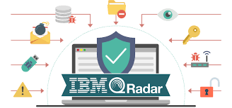
LONG TERM INTERNSHIP WITH SMART INTERNZ

CYBER SECURITY WITH IBM QRADAR
PROJECT TITLE:
Understanding Cyber Treads:Exploring The Nessus And Beyond Scanning Tools

TEAM INFORMATION
Team id:LTVIP2024TMID11414
Team Leader : GORUSU LOKESH REDDY
Team member : GUMMALA HARI NAIDU
Team member : KAMBALA RAJ KUMAR
Team member : SHAIK ABDUR RAAZIQ
Team member : YERRAMASETTI MADHAN

INDEX

 |  | Understanding Cyber Treads:Exploring The Nessus And Beyond Scanning Tools
S.NO |  | TITLES  AND SUBTITLES | PAGE  NO
1 |  | Introduction To Cyber Threats And Vulnerability Scanning | 1-11
 | 1.1 | Understanding Cyber Threats
 | 1.2 | Introduction To Nessus
 | 1.3 | Beyond Nessus: Overview Of Other Scanning Tools
 | 1.4 | Importance Of Vulnerability Management
 | 1.5 | Understanding Nessus Reports
2 |  | Planning And Preparation | 11  -15
 | 2.1 | Preparing The Environment
 | 2.2 | Scoping The Scan
 | 2.3 | Compliance And Regulatory Requirements
 | 2.4 | Resource Allocation And Scheduling
 | 2.5 | Stakeholder Communication
3 |  | Conducting Vulnerability Scans | 15  -19
 | 3.1 | Executing Nessus Scans
 | 3.2 | Interpreting Scan Results
 | 3.3 | Analysing Scan Findings
 | 3.4 | Addressing False Positives And False Negatives
 | 3.5 | Reporting And Documentation
4 |  | Remediation And Mitigation | 19  -24
 | 4.1 | Prioritising Remediation Efforts
 | 4.2 | Implementing Security Controls
 | 4.3 | Testing And Validation
 | 4.4 | Incident Response And Contingency Planning
 | 4.5 | Continuous Monitoring And Improvement
5 |  | Integration And Automation | 24  -28
 | 5.1 | Integrating With Security Information And Event Management (SIEM) Systems
 | 5.2 | Automating Scanning Workflows
 | 5.3 | Leveraging Threat Intelligence
 | 5.4 | Scalability And Flexibility
 | 5.5 | Monitoring And Reporting Automation
6 |  | Best Practices And Future Trends | 28-35
 | 6.1 | Best Practices In Vulnerability Management
 | 6.2 | Emerging Trends In Vulnerability Management
 | 6.3 | Case Studies And Use Cases
 | 6.4 | Continuous Learning And Professional Development
 | 6.5 | Conclusion And Recommendations

Introduction To Cyber Threats And Vulnerability Scanning

Understanding Cyber Threats
1.Malware: Malicious software designed to disrupt, damage, or gain unauthorised access to computer systems or data. This includes viruses, worms, Trojans, ransomware, and spyware.
2.Phishing: A deceptive technique where attackers masquerade as trustworthy entities to trick individuals into divulging sensitive information such as passwords, credit card numbers, or other personal data.
3.Denial-of-Service (DoS) and Distributed Denial-of-Service (DDoS) Attacks: These attacks aim to overwhelm a target system, network, or service with a flood of traffic, rendering it inaccessible to legitimate users.
4.Man-in-the-Middle (MitM) Attacks: In this type of attack, an attacker intercepts and possibly alters communications between two parties without their knowledge. This can be used to eavesdrop on sensitive information or inject malicious content.
5.SQL Injection: Attackers exploit vulnerabilities in web applications by inserting malicious SQL code into input fields, allowing them to manipulate databases or gain unauthorised access to sensitive data.
6.Cross-Site Scripting (XSS): Attackers inject malicious scripts into web pages viewed by other users. These scripts can steal information, manipulate web content, or redirect users to malicious sites.
7.Zero-Day Exploits: These are attacks that exploit vulnerabilities in software or hardware that are not yet known to the vendor or the public, giving attackers a significant advantage.
8.Insider Threats: Malicious or negligent actions by individuals within an organisation, such as employees or contractors, can pose serious risks to data security and integrity.

Introduction To Nessus

Features and Capabilities:
Vulnerability Scanning: Nessus scans networks for vulnerabilities, including software flaws, misconfigurations, and potential security threats.
Plugin Architecture: It offers a vast repository of plugins that cover a wide range of vulnerabilities across operating systems, applications, and network devices.
Compliance Auditing: Nessus helps organisations ensure compliance with various regulatory standards such as PCI DSS, HIPAA, and GDPR by conducting audits and providing reports on compliance status.
Asset Discovery: It can identify and map network assets, including devices, servers, and endpoints, providing visibility into the organisation's IT infrastructure.
Configuration Auditing: Nessus checks system configurations against best practices and security benchmarks, identifying deviations that could pose security risks.
Customization: Users can customise scans based on their specific requirements, including target selection, scan frequency, and reporting preferences.
Integration: Nessus integrates with other security tools and platforms, enabling automated workflows and centralised management of vulnerability data.

Installation Process:
Download Nessus: Go to the Tenable website and download the appropriate installer for your operating system (Windows, Linux, or macOS).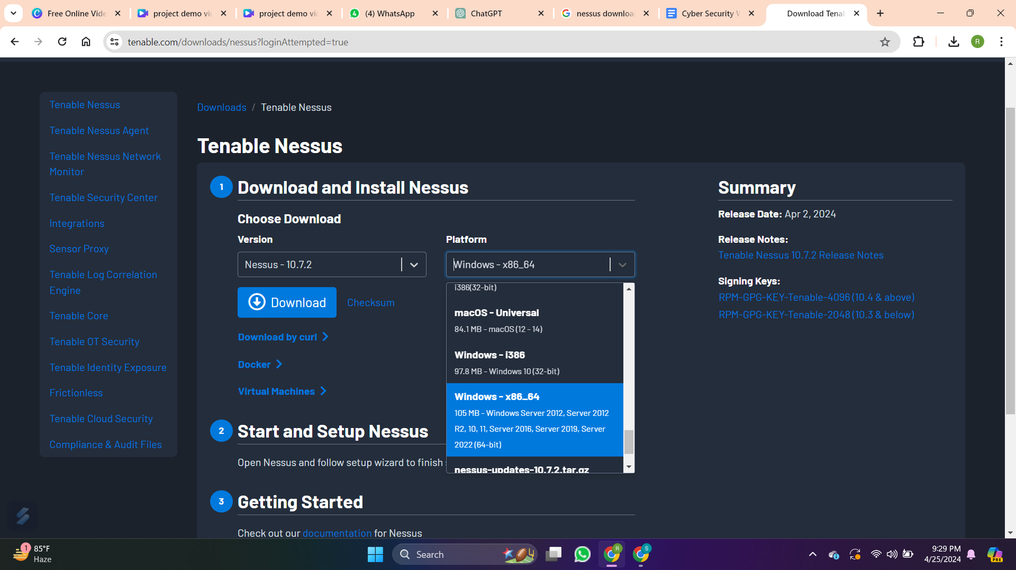
Run the Installer: Once the installer is downloaded, double-click on it to run the installation wizard.
Follow Installation Steps: The installation wizard will guide you through the installation process. Follow the on-screen instructions to select installation options such as installation directory, components to install, and start menu shortcuts.
Complete Installation: Once the installation is complete, you may be prompted to launch Nessus immediately or you can manually launch it from the start menu or desktop shortcut.
Setup Process: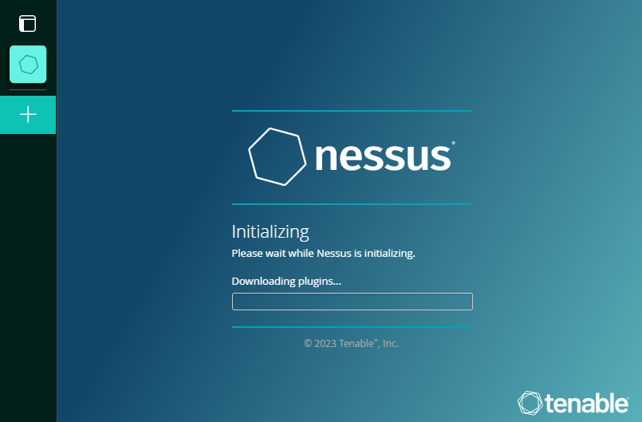
Activation: When you first launch Nessus, you will be prompted to activate your licence. Enter the activation code provided to you by Tenable or log in with your Tenable account credentials if you have a subscription.
Accept Licence Agreement: Review and accept the Nessus licence agreement.
Create Admin User: Create an administrator account for Nessus. This account will be used to log in and manage Nessus settings.
Configure Scanning Preferences: Set up scanning preferences such as target IP ranges, scan schedules, scan policies, and notification settings according to your organisation's requirements.
Network Configuration: Configure network settings such as proxy settings (if applicable) and network interfaces for scanning.
Plugin Update: Nessus will automatically check for plugin updates. Allow the updates to download and install to ensure Nessus has the latest vulnerability detection capabilities.
Start Scanning: Once setup is complete, you can start scanning your network for vulnerabilities by creating new scans based on your configured preferences.

Licensing Options: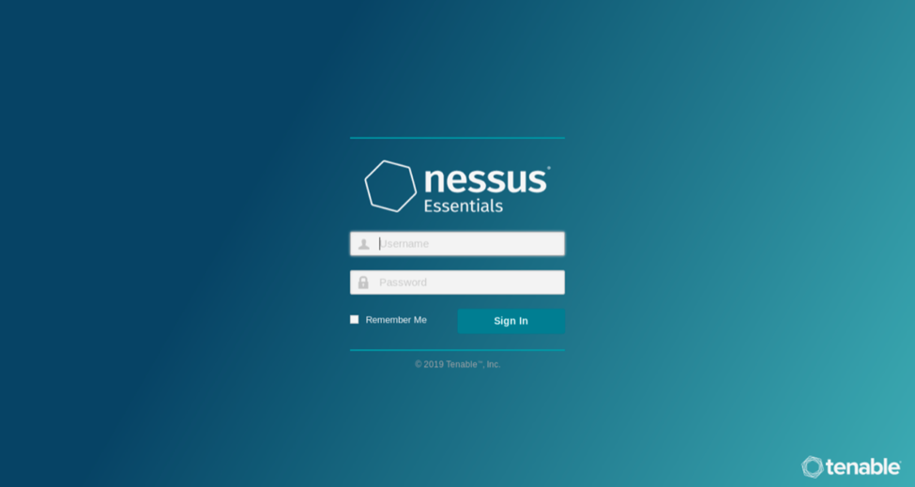
Nessus offers different licensing options tailored to the needs of different organisations, including:
Nessus Professional: Designed for individual users, small businesses, and consultants, offering basic vulnerability scanning capabilities.
Nessus Manager: Provides centralised management of multiple Nessus scanners, along with advanced reporting and collaboration features.
Nessus Cloud: A cloud-based solution that offers scalability, flexibility, and simplified deployment, suitable for organisations with dynamic or distributed IT environments.
Nessus Home: A free version of Nessus for personal, non-commercial use, limited to scanning up to 16 IP addresses.
Basic Scanning Techniques:
Discovery Scan: Identifies live hosts and open ports on the network.
Vulnerability Scan: Identifies known vulnerabilities and security issues on target systems.
Credential-based Scan: Authenticates to target systems using credentials (e.g., username and password) to perform more thorough scans and access additional information.
Compliance Scan: Checks system configurations against predefined compliance policies to ensure adherence to regulatory standards.

Beyond Nessus: Overview Of Other Scanning Tools

1. Qualys Vulnerability Management:

Comparison with Nessus: Qualys offers a cloud-based vulnerability management platform that provides comprehensive scanning capabilities similar to Nessus. It boasts a large database of vulnerabilities and supports a wide range of assets.
Advantages:
- Scalability: Suitable for large enterprises with distributed IT environments.
Cloud-Based: Offers flexibility and ease of deployment without the need for on-premises infrastructure.
Continuous Monitoring: Provides continuous scanning and monitoring capabilities.
Disadvantages:
- Cost: Can be more expensive than Nessus, especially for larger deployments.
Dependency on Internet Connection: Requires a stable internet connection for cloud-based operations.
Use Cases: Suitable for organisations looking for a scalable, cloud-based vulnerability management solution with continuous monitoring capabilities.

2. OpenVAS (Open Vulnerability Assessment System):

Comparison with Nessus: OpenVAS is an open-source vulnerability scanning tool that offers similar features to Nessus. It provides scanning of networks and hosts for known vulnerabilities and misconfigurations.
Advantages:
- Open-Source: Free to use and customise, making it accessible to small businesses and individuals.
- Active Community: Supported by a vibrant open-source community, leading to regular updates and improvements.
- Extensibility: Allows for integration with other security tools and custom scripting.
Disadvantages:
- Complexity: Setup and configuration can be more complex compared to commercial tools like Nessus.
- Plugin Quality: The quality and coverage of vulnerability detection may not be as extensive as commercial solutions.
Use Cases: Ideal for organisations with limited budgets or those looking for an open-source vulnerability scanning tool that can be customised and integrated into existing workflows.

3. Rapid7 InsightVM:
Comparison with Nessus: InsightVM is a vulnerability management solution by Rapid7 that provides comprehensive scanning and remediation capabilities. It offers features similar to Nessus but with additional capabilities such as remediation workflow automation.
Advantages:
- Remediation Workflow: Offers automated remediation workflows to streamline the vulnerability management process.
- Integration: Integrates with other Rapid7 solutions and third-party tools for enhanced functionality.
- Reporting: Provides detailed and customizable reports for compliance and risk management.
Disadvantages:
- Cost: Can be more expensive than Nessus, especially for organisations requiring advanced features and support.
- Complexity: Advanced features may require additional training and expertise to fully leverage.
Use Cases: Suited for organisations looking for an integrated vulnerability management solution with automated remediation workflows and advanced reporting capabilities.

Considerations for Tool Selection:

Budget: Consider the cost of the tool and whether it aligns with your organisation's budgetary constraints.
Scalability: Evaluate the scalability of the tool to ensure it can meet your organisation's current and future needs.
Features: Assess the features and capabilities of the tool, such as scanning depth, reporting capabilities, and integration options.
Ease of Use: Consider the ease of installation, setup, and ongoing maintenance of the tool.
Support and Documentation: Look for tools that offer comprehensive support options and documentation to assist with troubleshooting and optimization.
Compliance Requirements: Ensure the tool meets any specific compliance requirements relevant to your organisation's industry or region.

Importance Of Vulnerability Management

1.Role of Vulnerability Management in Cybersecurity:
Risk Reduction: Vulnerability management helps organisations mitigate security risks by identifying and addressing vulnerabilities before they can be exploited by attackers.
Asset Protection: It helps protect sensitive data and critical assets by ensuring that systems and applications are properly configured and updated to defend against potential threats.
Compliance Assurance: Vulnerability management assists organisations in meeting regulatory compliance requirements by regularly scanning for vulnerabilities and addressing any issues that may impact compliance.
Incident Prevention: By proactively addressing vulnerabilities, organisations can reduce the likelihood of security incidents, data breaches, and service disruptions.

2.Benefits of Proactive Vulnerability Scanning:
Early Detection: Proactive vulnerability scanning allows organisations to detect vulnerabilities early in the development lifecycle, minimising the window of exposure to potential threats.
Risk Prioritisation: It helps organisations prioritise remediation efforts by identifying critical vulnerabilities that pose the highest risk to the organisation's security posture.
Cost Savings: Identifying and addressing vulnerabilities proactively can help organisations avoid the potentially significant costs associated with data breaches, compliance violations, and system downtime.
Improved Security Posture: Regular vulnerability scanning and remediation efforts contribute to a stronger overall security posture, reducing the organisation's susceptibility to cyber attacks.

3.Challenges in Vulnerability Management:
Complexity: Managing vulnerabilities across a diverse IT environment can be complex, particularly in large organisations with numerous systems and applications.
Resource Constraints: Limited resources, including time, budget, and expertise, can pose challenges in effectively managing vulnerabilities, prioritising remediation efforts, and keeping up with the evolving threat landscape.
Patch Management: Patching vulnerabilities may disrupt business operations or require coordination across multiple teams, leading to delays in remediation.
Detection Accuracy: Vulnerability scanning tools may produce false positives or miss certain vulnerabilities, requiring manual verification and validation.

4.Compliance and Regulatory Considerations:
Industry Standards: Compliance requirements such as PCI DSS, HIPAA, GDPR, and others often mandate regular vulnerability assessments and remediation efforts.
Audits and Reporting: Compliance regulations typically require organisations to maintain records of vulnerability scans, remediation activities, and compliance status for audit purposes.
Penalties and Fines: Non-compliance with regulatory requirements can result in significant penalties, fines, and reputational damage for organisations.
5.Integration with Other Security Processes:
Incident Response: Vulnerability management feeds into incident response processes by providing early detection of potential security threats and vulnerabilities that may lead to incidents.
Security Information and Event Management (SIEM): Integration with SIEM platforms allows organisations to correlate vulnerability data with other security events for better threat detection and response.
Patch Management: Vulnerability management processes often integrate with patch management systems to automate the deployment of patches and updates to address identified vulnerabilities.
Risk Management: Vulnerability data can inform risk management processes by providing insights into the organisation's risk exposure and helping prioritise mitigation efforts based on risk severity.

Understanding Nessus Reports

1.Structure of Nessus Reports:
- Nessus reports are typically organised into sections such as Executive Summary, Vulnerabilities by Severity, Hosts Summary, and Detailed Findings.
- The Executive Summary provides a concise overview of the scan results, highlighting the number of vulnerabilities detected, their severity levels, and potential risks.
- Vulnerabilities by Severity section categorises vulnerabilities based on their severity levels, such as Critical, High, Medium, and Low.
- Hosts Summary presents a summary of vulnerabilities detected on each scanned host.
- Detailed Findings offer comprehensive information about each identified vulnerability, including its CVE identifier, description, affected hosts, and remediation recommendations.
2.Key Elements and Findings:
- Key elements in Nessus reports include vulnerability details (CVE identifiers, descriptions, affected hosts), severity levels, compliance checks, and potential security risks.
- Findings encompass vulnerabilities, misconfigurations, security policy violations, and other issues discovered during the scan.

3.Common Vulnerabilities and Exposures (CVEs):
- Nessus identifies vulnerabilities using CVE identifiers, which provide a standardised reference for known security weaknesses.
- CVEs are associated with specific vulnerabilities and enable security professionals to research and understand the nature of the issues detected.

4.Prioritization of vulnerabilities
- Prioritisation involves assessing the severity, exploitability, and potential impact of vulnerabilities.
- Critical and high-severity vulnerabilities should be addressed with the highest priority to mitigate significant risks.
- Prioritisation may also consider factors such as the relevance of vulnerabilities to the organisation's systems and infrastructure.

5.Interpretation of Scan Results:
- Interpreting Nessus scan results requires analysing the findings to understand the overall security posture of the scanned environment.
- This includes identifying recurring issues, trends, and areas of particular concern.
- Interpretation involves distinguishing true vulnerabilities from false positives and verifying findings through further investigation if necessary.
- Actionable insights derived from interpretation inform remediation efforts and help improve the organisation's security posture.

Planning And Preparation

Preparing The Environment

1.Identifying Target Systems:
- Define Scan Targets:
- In Nessus, navigate to the "New Scan" or "Scan" tab, depending on your Nessus interface version.
- Start creating a new scan or edit an existing one.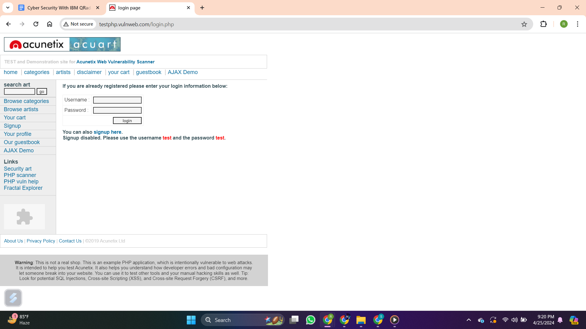
- Look for the section where you can specify the target for the scan. This section may be labelled as "Targets," "Hosts," or "Assets."
- Specify IP Addresses or Hostnames:
- Enter the IP addresses, hostnames, or IP ranges of the target systems you want to scan.
- You can specify individual IP addresses (e.g., 192.168.1.100), hostnames (e.g., example.com), or IP ranges using CIDR notation (e.g., 192.168.1.0/24).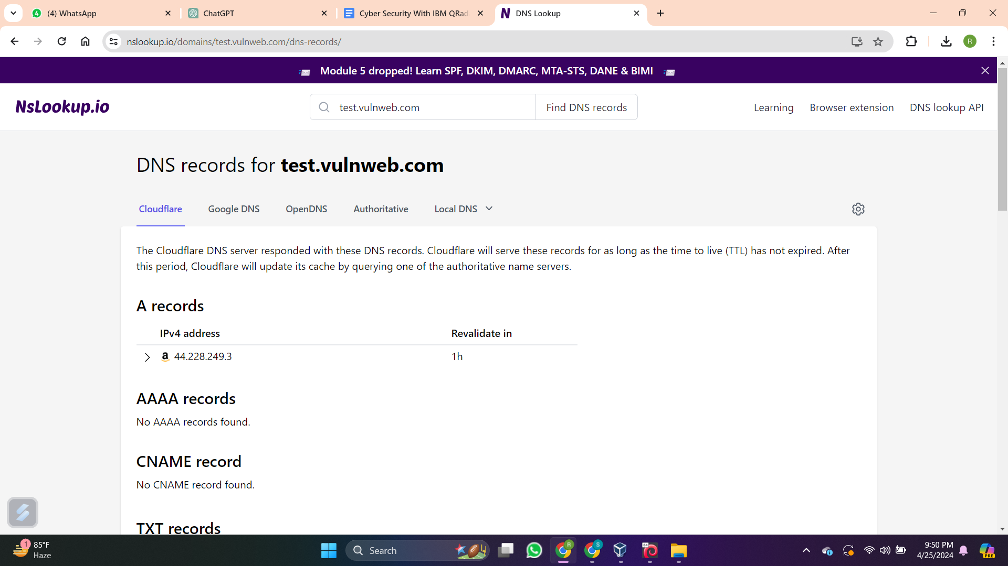
- Advanced Target Options:
- Nessus provides advanced options for defining scan targets, such as excluding certain IPs or specifying targets based on DNS names.
- You can exclude specific IPs from the scan by entering them in the "Exclusions" section.
- Additionally, you can choose to scan targets by DNS name rather than IP address by selecting the appropriate option.
- Save and Run the Scan:
- Once you have specified the target systems, review the scan settings to ensure they are accurate.
- Save the scan configuration and initiate the scan process.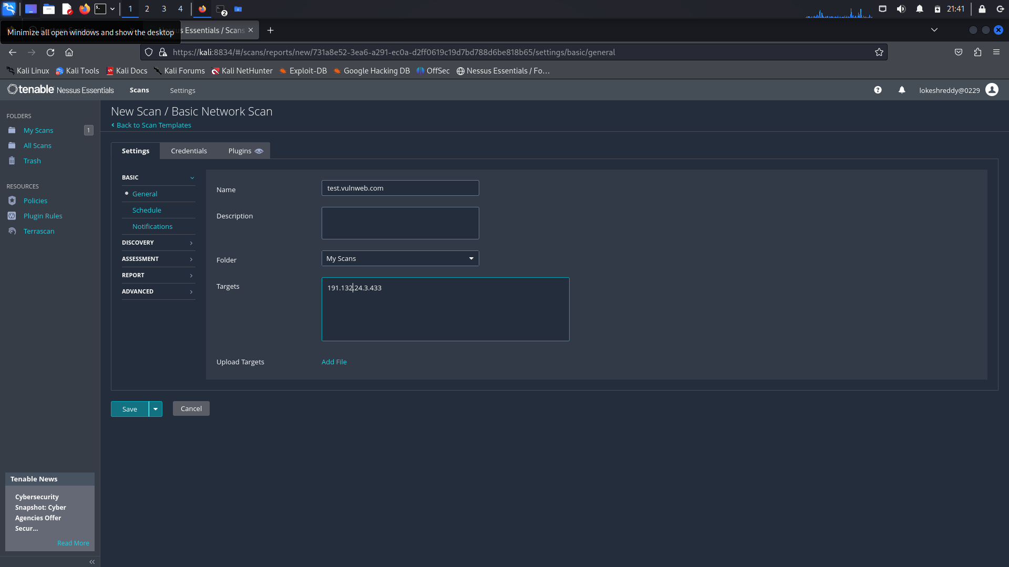

2.Network Segmentation Considerations:
- Evaluate the network architecture to determine if segmentation is implemented effectively.
- Network segmentation divides the network into smaller, isolated segments to minimise the impact of security breaches and control the flow of traffic.
- Assess the segmentation strategy to ensure that critical assets are adequately isolated and protected from unauthorised access.
- Review firewall configurations, VLAN configurations, and access control lists (ACLs) to enforce segmentation rules.

3.Asset Inventory and Classification:
- Create a comprehensive inventory of network assets, including servers, workstations, routers, switches, firewalls, and other network devices.
- Classify assets based on their criticality, importance to business operations, sensitivity of data they handle, and compliance requirements.
- Regularly update the asset inventory to reflect changes in the network environment, such as new deployments, decommissioned systems, or changes in configurations.

4.Access Control and Permissions:
- Review access control mechanisms to ensure that only authorised users have access to network resources and sensitive data.
- Implement the principle of least privilege, granting users only

Compliance And Regulatory Requirements

1.Understanding Compliance Standards:
- Familiarise yourself with relevant compliance standards such as PCI DSS, HIPAA, GDPR, etc.
- Understand the specific security and privacy requirements outlined in each standard, including mandatory controls and best practices.

2.Mapping Regulatory Requirements to Scanning Activities:
- Identify how each compliance standard relates to vulnerability scanning and network security.
- Determine which scanning activities are necessary to meet the requirements of each standard, such as regular vulnerability assessments, configuration checks, and patch management.

3.Ensuring Compliance with Industry Standards:
- Configure Nessus scans to align with the requirements of relevant compliance standards.
- Utilise built-in compliance checks and audit policies provided by Nessus to assess the security posture of your systems and networks against specific standards.

4.Incorporating Compliance Checks into Scanning Process:
- Integrate compliance checks into your scanning process by selecting appropriate audit policies or templates within Nessus.
- Customise scan configurations to include compliance checks relevant to the standards your organisation needs to adhere to.
5.Documentation and Reporting for Compliance Purposes:
- Generate comprehensive reports from Nessus scans that document compliance status, vulnerabilities, and remediation efforts.
- Ensure that reports clearly outline compliance with industry standards and regulatory requirements, highlighting any areas of non-compliance or potential risks.
- Retain documentation of scanning activities, audit trails, and remediation actions for regulatory purposes and internal audits.

Resource Allocation And Scheduling

1.Allocation of Resources:
- Determine the resources needed for scanning activities, including time, personnel, and tools.
- Allocate sufficient resources based on the scope and complexity of scanning tasks, ensuring that personnel have the necessary expertise to conduct scans effectively.

2.Determining Scanning Frequency:
- Assess the organisation's risk tolerance, compliance requirements, and operational needs to determine the frequency of scanning.
- Consider factors such as the rate of system changes, patch management cycles, and emerging threats when establishing scanning schedules.

3.Coordination with IT and Security Teams:
- Collaborate closely with IT and security teams to coordinate scanning activities.
- Ensure alignment between scanning schedules and IT maintenance windows to minimise disruptions to operations.

4.Scheduling Scans to Minimise Impact on Operations:
- Schedule scans during off-peak hours or low-traffic periods to minimise impact on network performance and user productivity.
- Prioritise critical systems and assets for scanning to focus resources on areas of highest risk.

5.Contingency Planning for Unexpected Issues:
- Develop contingency plans to address unexpected issues that may arise during scanning activities, such as network outages or system failures.
- Maintain backup scanning configurations and procedures to quickly resume scanning activities in the event of disruptions.
- Establish communication channels and escalation procedures to notify stakeholders of any significant issues or delays.

Stakeholder Communication

1.Communicating with Stakeholders about Scanning Activities:
- Clearly outline the purpose, scope, and benefits of scanning activities to stakeholders, including management, IT teams, and relevant departments.
- Provide details on the methodology, tools, and timelines for scans, ensuring stakeholders understand the process.

2.Obtaining Approvals and Buy-In from Management:
- Present a compelling case for the importance of scanning in maintaining security posture, identifying vulnerabilities, and meeting compliance requirements.
- Highlight potential risks and consequences of not conducting scans, emphasising the need for proactive security measures.
- Secure approvals from management by demonstrating the value and ROI of investing in scanning tools like Nessus.

3.Educating Users and Stakeholders about the Importance of Scanning:
- Develop training sessions, workshops, or informational materials to educate users and stakeholders about the role of scanning in cybersecurity.
- Emphasise the significance of scanning in protecting sensitive data, preventing breaches, and maintaining business continuity.
- Tailor educational efforts to the specific needs and knowledge levels of different stakeholders.

4.Providing Updates on Scanning Progress and Results:
- Regularly communicate scanning progress, findings, and results to stakeholders through reports, presentations, or meetings.
- Highlight notable vulnerabilities, trends, and areas for improvement, along with recommendations for remediation.
- Ensure that updates are timely, concise, and actionable, facilitating informed decision-making and prioritisation of security efforts.

5.Addressing Concerns and Feedback from Stakeholders:
- Foster an open and transparent communication environment where stakeholders feel comfortable expressing concerns and providing feedback.
- Actively listen to stakeholders' perspectives, validate their concerns, and offer solutions or explanations where possible.
- Incorporate stakeholder feedback into future scanning activities, demonstrating a commitment to continuous improvement and responsiveness to stakeholders' needs.

Conducting Vulnerability Scans

Executing Nessus Scans

1.Initiating Scans using Nessus Interface:

Log in to the Nessus web interface using your credentials.
- Navigate to the "Scans" tab and click on "New Scan" to create a new scan.
- Choose the scan type (e.g., Basic Network Scan, Advanced Scan) based on your requirements.
2.Configuring Scan Options and Settings:
- Specify the target(s) for the scan by providing IP addresses, hostnames, or ranges.
- Configure scan options such as scan policy (e.g., default, compliance), scan frequency, scan intensity, and desired plugins.
- Customise advanced settings such as port scanning options, credentials for authenticated scans, and scan exclusions if needed.

3.Monitoring Scan Progress:
- Once the scan is initiated, monitor its progress from the Nessus dashboard.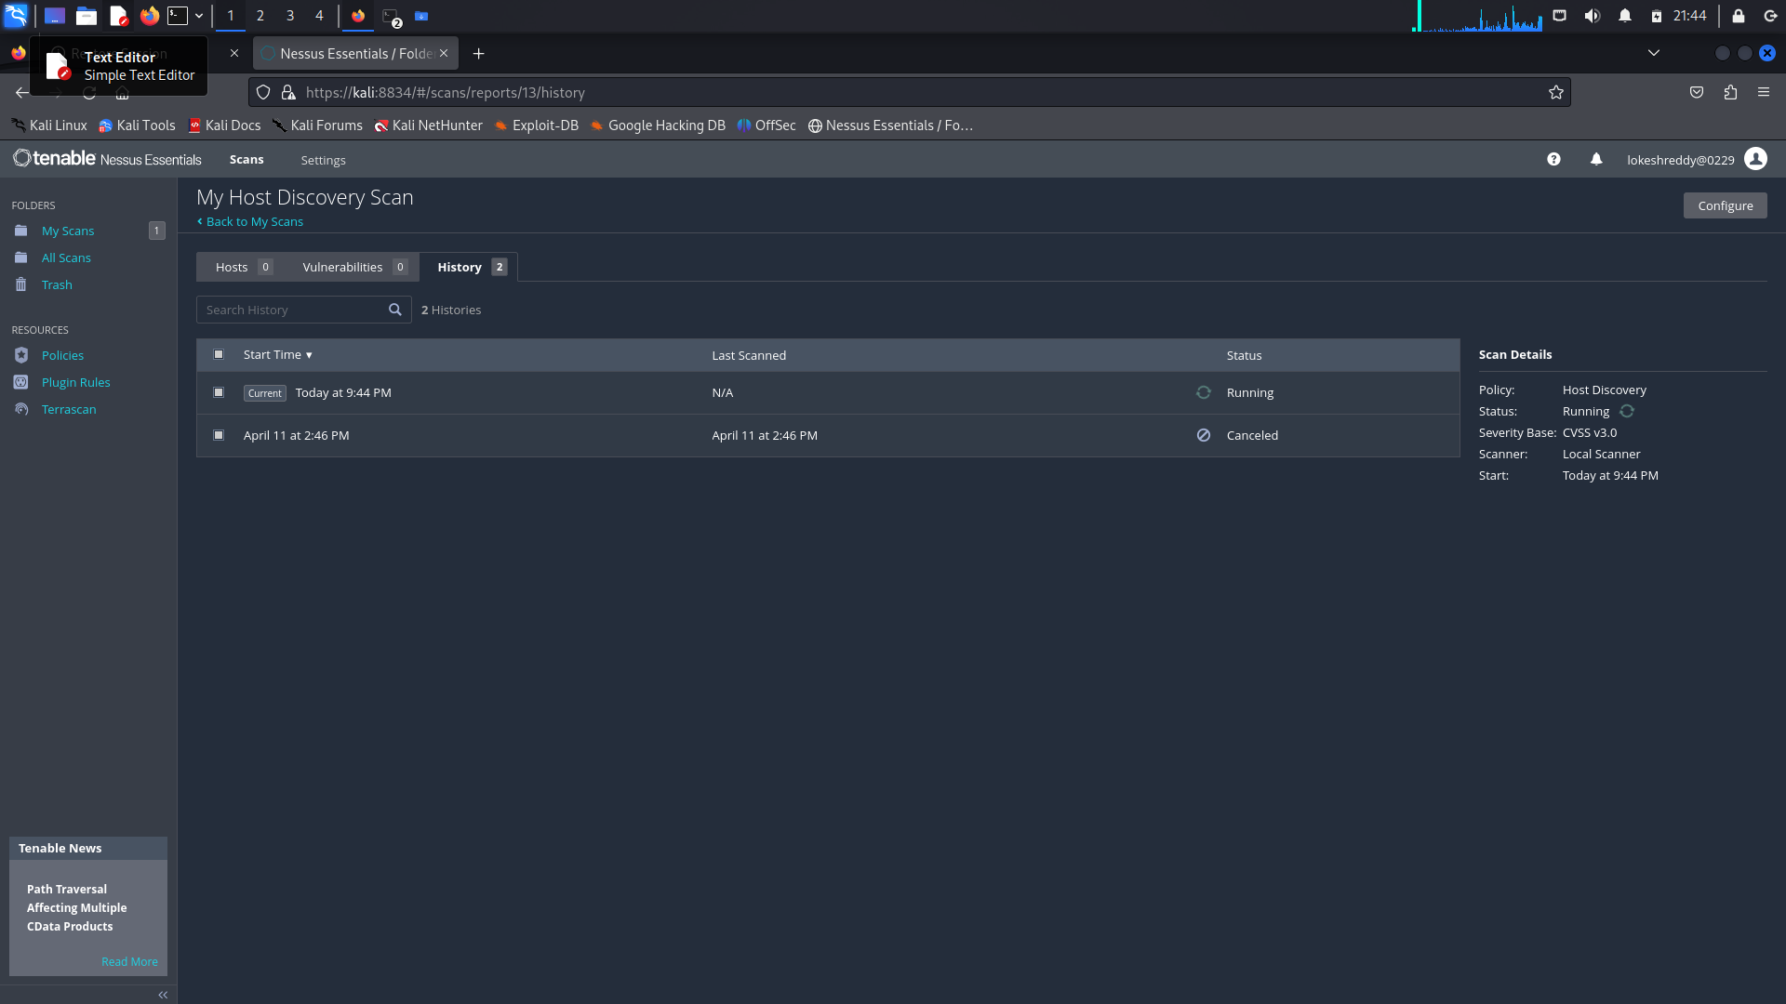
- Check the scan status, including the number of hosts scanned, vulnerabilities detected, and remaining time.
- Use the scan log and activity feed to track scanning activities in real-time.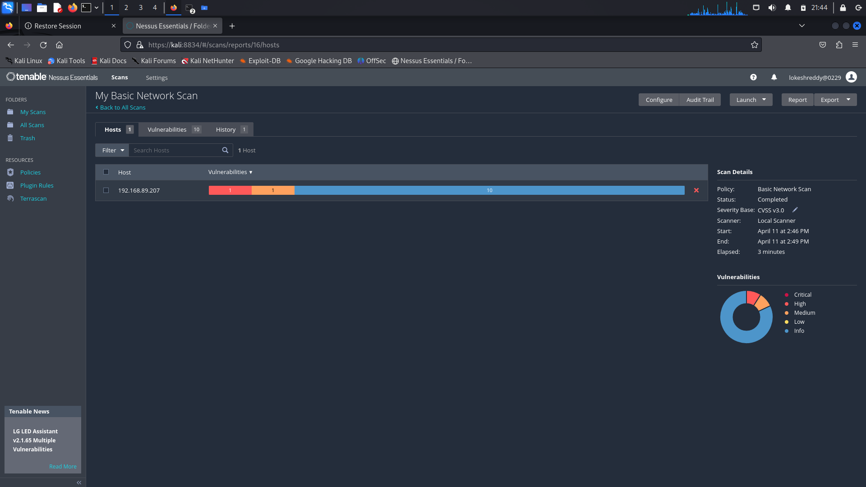

4.Troubleshooting Common Issues:
- Monitor for any errors or warnings during the scan process and investigate them promptly.
- Common issues may include connectivity problems, authentication failures, or plugin errors.
- Utilise Nessus documentation, community forums, or support resources to troubleshoot and resolve issues effectively.

5.Ensuring Scans are Performed Securely and Efficiently:
- Follow best practices for secure scanning, such as ensuring Nessus is up-to-date with the latest patches and security updates.
- Configure Nessus to use secure communication protocols (e.gHTTPS) and implement proper access controls to restrict unauthorised access.
- Optimise scan settings to balance thoroughness with efficiency, considering factors such as network bandwidth and system resource utilisation.
- Regularly review and update scan policies, plugins, and configurations to adapt to evolving security threats and organisational requirements.

Interpreting Scan Results

1.Reviewing Nessus Reports:
- Access the Nessus reports from the scan results section in the Nessus interface.
- Review the summary section for an overview of the scan findings, including the number of hosts scanned, vulnerabilities detected, and severity levels.
- Dive into the detailed findings section to explore individual vulnerabilities, affected hosts, and remediation recommendations.

2.Identifying Critical Vulnerabilities:
- Focus on vulnerabilities classified as critical or high severity, as they pose the greatest risk to your organisation.
- Look for vulnerabilities that could lead to unauthorised access, data breaches, or service disruptions if exploited by attackers.

3.Prioritizing Vulnerabilities Based on Severity:
- Prioritise vulnerabilities based on their severity ratings (e.g., CVSS score), exploitability, and potential impact on business operations.
- Consider additional factors such as the affected assets' criticality, exposure to external threats, and relevance to compliance requirements.

4.Understanding False Positives and False Negatives:
- Evaluate each identified vulnerability for the possibility of false positives (incorrectly flagged as vulnerabilities) or false negatives (missed vulnerabilities).
- Cross-reference Nessus findings with manual verification, other scanning tools, or external sources to validate their accuracy.
- Adjust scan configurations, plugin settings, or exclusions to minimise false positives and improve accuracy.

5.Investigating Potential Security Risks:
- Investigate vulnerabilities that may not have been automatically classified as critical but still pose significant security risks based on your organisation's context.
- Consider factors such as the presence of sensitive data, potential attack vectors, and the likelihood of exploitation when assessing security risks.
- Collaborate with IT and security teams to understand the root causes of vulnerabilities and develop appropriate remediation strategies.

Analysing Scan Findings
1.Assessing the Impact of Vulnerabilities:
- Evaluate the severity and potential consequences of each identified vulnerability, considering factors such as the affected assets' criticality and exposure to threats.
- Assess the likelihood of exploitation based on vulnerability characteristics, exploitability, and existing mitigating controls.

2.Identifying Potential Attack Vectors:
- Determine how attackers could exploit identified vulnerabilities to compromise systems or networks.
- Analyse potential attack vectors, such as network-based attacks, web application vulnerabilities, misconfigurations, or insider threats.

3.Correlating Findings with Known Threats:
- Cross-reference Nessus scan findings with known vulnerabilities, exploits, malware, and attack techniques documented in threat intelligence sources.
- Identify any matches between identified vulnerabilities and known threats to assess the level of risk posed by each vulnerability.

4.Performing Risk Assessments:
- Conduct risk assessments to quantify the overall risk exposure associated with identified vulnerabilities.
- Consider the likelihood and impact of exploitation, as well as any existing controls or compensating measures in place.
- Prioritise vulnerabilities based on their risk level, focusing on those with the highest potential impact on the organisation.

5.Recommending Mitigation Strategies:
- Recommend mitigation strategies and countermeasures to address identified vulnerabilities and reduce risk.
- Tailor mitigation recommendations to the specific characteristics of each vulnerability and the organisation's risk tolerance.
- Prioritise mitigation efforts based on the severity of vulnerabilities, available resources, and business priorities.

Addressing False Positives And False Negatives
1.Investigating False Positive Findings:
- Review each flagged vulnerability identified by Nessus as a false positive.
- Verify the existence of the reported vulnerability by manually inspecting the affected systems or using alternative scanning tools.
- Investigate the root cause of false positives, which may include misconfigurations, false interpretations of benign conditions, or inaccuracies in Nessus plugins.

2.Adjusting Scan Configurations to Reduce False Positives:
- Fine-tune Nessus scan configurations to minimise false positives by adjusting scan settings and plugin preferences.
- Customise scan policies to exclude known false positive conditions or non-relevant findings based on your organisation's environment and requirements.
- Disable specific plugins or tweak their sensitivity levels if they consistently produce false positives.

3.Identifying False Negative Findings:
- Review the Nessus scan results and look for potential false negatives—vulnerabilities that were missed or not detected during the scan.
- Use manual verification methods, additional scanning tools, or external vulnerability databases to identify vulnerabilities that Nessus may have overlooked.

4.Enhancing Scanning Techniques to Minimise False Negatives:
- Optimise Nessus scan configurations to improve coverage and detection capabilities, especially for vulnerabilities prone to being missed (e.g., zero-day exploits, custom vulnerabilities).
- Incorporate additional scanning techniques, such as authenticated scanning, to access deeper levels of system information and identify vulnerabilities that may not be visible externally
.
5.Documenting Actions Taken to Address False Results:
- Maintain detailed documentation of false positive and false negative findings, including the steps taken to investigate and address them.
- Document adjustments made to Nessus scan configurations, plugin settings, or exclusion criteria to mitigate false positives and improve scan accuracy.
- Regularly review and update the documentation as new vulnerabilities are discovered, scanning techniques evolve, and organisational requirements change.

Reporting And Documentation
1.Compiling Comprehensive Reports of Scan Findings:
- Utilise Nessus to generate detailed reports summarising scan findings, including vulnerabilities, affected systems, severity levels, and remediation recommendations.
- Customise report settings to include relevant details such as scan configurations, scan dates, and executive summaries.

2.Summarizing Key Vulnerabilities and Recommendations:
- Provide a concise summary of key vulnerabilities identified during the scan, focusing on critical and high-risk findings.
- Include actionable recommendations for remediation, prioritised based on severity, exploitability, and potential impact.

3.Generating Actionable Insights for Remediation:
- Translate technical findings into actionable insights for remediation, considering the organisation's risk tolerance, resources, and business priorities.
- Include clear instructions, step-by-step guidance, and recommended timelines for addressing identified vulnerabilities.

4.Customizing Reports for Different Stakeholders:
- Tailor report formats and content to meet the needs and preferences of different stakeholders, such as executive leadership, IT teams, and compliance officers.
- Customise report templates, headers, footers, and branding elements to align with organisational standards and expectations.

5.Archiving Scan Reports for Future Reference and Auditing:
- Establish a centralised repository for storing Nessus scan reports, ensuring they are easily accessible for future reference, auditing, and compliance purposes.
- Implement version control and retention policies to manage the storage and archival of scan reports over time.

Remediation And Mitigation

Prioritising Remediation Efforts
1.Developing a Remediation Plan:
- Create a structured remediation plan that outlines the process for addressing identified vulnerabilities.
- Define roles and responsibilities for key stakeholders involved in the remediation process, including IT teams, security personnel, and business units.
- Establish communication channels and escalation procedures to facilitate collaboration and decision-making throughout the remediation process.

2.Prioritizing Vulnerabilities Based on Risk:
- Evaluate vulnerabilities based on risk factors such as severity, exploitability, exposure, and potential impact on business operations.
- Prioritise vulnerabilities with the highest risk level, focusing on critical and high-severity issues that pose the greatest threat to the organisation.

3.Considering Business Impact and Criticality:
- Take into account the business impact and criticality of affected systems or assets when prioritising remediation efforts.
- Assess the potential consequences of a successful exploit, including financial losses, reputational damage, regulatory fines, and operational disruptions.

4.Aligning Remediation Efforts with Organisational Goals:
- Ensure that remediation efforts are aligned with organisational goals, strategic objectives, and risk tolerance.
- Consider broader security initiatives, compliance requirements, and industry best practices when developing remediation strategies.

5.Establishing Timelines for Remediation Activities:
- Define realistic timelines and deadlines for remediating identified vulnerabilities, taking into account the complexity of remediation tasks, available resources, and business priorities.
- Set interim milestones and checkpoints to track progress and ensure timely completion of remediation activities.
- Communicate timelines and expectations to stakeholders, and regularly monitor and update progress against established deadlines.

Implementing Security Control

1.Deploying Patches and Updates:
- Establish a patch management process to regularly identify, prioritise, and deploy security patches and updates for operating systems, software, and firmware.
- Use centralised patch management tools to streamline patch deployment across distributed environments and automate patching where possible.
- Develop procedures for testing patches in a controlled environment before deployment to minimise the risk of system disruptions.

2.Configuring Security Settings:
- Configure security settings on systems and network devices to enforce least privilege, strong authentication, encryption, and access controls.
- Implement security configurations based on industry best practices, security baselines, and compliance requirements such as CIS benchmarks or NIST guidelines.
- Regularly review and update security configurations to address emerging threats and vulnerabilities.

3.Implementing Compensating Controls:
- Identify gaps in existing security controls and implement compensating controls to mitigate residual risks.
- Compensating controls should address security requirements in situations where primary controls are not feasible or effective.

4.Hardening Systems and Networks:
- Harden systems and network devices by removing unnecessary services, disabling unused ports, and limiting access to sensitive resources.
- Follow security hardening guidelines provided by vendors or industry organisations to secure operating systems, applications, and infrastructure components.
- Implement measures such as intrusion detection/prevention systems, firewalls, and network segmentation to mitigate the impact of security incidents.

Automating Security Measures Where Possible:
- Leverage automation tools and scripts to automate routine security tasks such as vulnerability scanning, configuration management, and incident response.
- Implement continuous monitoring solutions that can automatically detect and respond to security threats in real-time.
- Integrate security controls into the software development lifecycle (SDLC) and DevOps processes to automate security testing, code analysis, and deployment security checks.

Testing And Validation
1.Conducting Post-Remediation Scans:
- After implementing remediation measures, conduct follow-up scans using Nessus or similar vulnerability assessment tools to reevaluate the security posture of systems and networks.
- Compare post-remediation scan results with baseline scans to identify any residual vulnerabilities or new security issues introduced during remediation.

2.Verifying the Effectiveness of Remediation Efforts:
- Analyse post-remediation scan findings to verify that identified vulnerabilities have been successfully addressed and mitigated.
- Validate that patches have been applied, configurations have been updated, and security controls have been implemented as intended.
- Verify the absence of false positives and confirm that false negatives have been addressed appropriately.

3.Validating that Vulnerabilities Have Been Addressed:
- Verify the closure of identified vulnerabilities through manual validation, configuration reviews, or additional testing as necessary.
- Ensure that vulnerabilities are resolved in accordance with established remediation procedures and security best practices.

4.Performing Penetration Testing and Security Assessments:
- Conduct penetration testing and security assessments to simulate real-world attack scenarios and identify potential security weaknesses that may not be captured by automated scans.
- Engage experienced security professionals or third-party penetration testing firms to perform thorough assessments and provide actionable recommendations for improving security posture.

5.Iterating on Remediation Strategies as Needed:
- Continuously evaluate the effectiveness of remediation strategies and adjust them based on feedback, lessons learned, and evolving threats.
- Iterate on remediation efforts by prioritising high-impact vulnerabilities, refining remediation processes, and enhancing security controls to address emerging risks.
- Foster a culture of continuous improvement and collaboration between IT, security, and business stakeholders to ensure that remediation efforts remain aligned with organisational goals and risk tolerance.

Incident Response And Contingency Planning
1.Developing Incident Response Procedures:
- Create comprehensive incident response procedures that outline the steps to be taken in the event of a security incident.
- Define roles and responsibilities for incident responders, including IT staff, security personnel, and management.
- Specify incident classification criteria, escalation procedures, and communication protocols.

2.Establishing Communication Channels During Incidents:
- Implement communication channels and tools for reporting and coordinating incident response efforts.
- Ensure that communication channels are secure, reliable, and accessible to relevant stakeholders.
- Establish clear channels for internal communication (e.g., email, instant messaging, phone) and external communication (e.g., with third-party vendors, law enforcement, regulatory authorities).

3.Identifying Escalation Paths:
- Define escalation paths for escalating incidents based on severity, impact, and complexity.
- Establish criteria for escalating incidents to higher levels of management or engaging external resources such as incident response teams or legal counsel.
- Ensure that escalation paths are well-documented and readily accessible to incident responders.

4.Creating Backups and Disaster Recovery Plans:
- Develop backup and disaster recovery plans to ensure the availability and integrity of critical data and systems in the event of a security incident or disruptive event.
- Regularly back up essential data and systems, and store backups securely in off-site or cloud-based locations.
- Test backup and recovery procedures regularly to verify their effectiveness and identify any potential issues or gaps.

5.Training Personnel on Incident Response Protocols:
- Provide regular training and awareness programs to educate personnel on incident response protocols, procedures, and best practices.
- Conduct tabletop exercises and simulations to practise incident response scenarios and test the effectiveness of response plans.
- Ensure that personnel are familiar with their roles and responsibilities during an incident and understand how to report security incidents promptly.

Continuous Monitoring And Improvement
1.Implementing Continuous Monitoring Processes:
- Deploy automated monitoring tools and systems to continuously monitor networks, systems, and applications for security events and anomalies.
- Utilise intrusion detection systems (IDS), security information and event management (SIEM) platforms, and endpoint detection and response (EDR) solutions to detect and respond to security incidents in real-time.
- Establish monitoring dashboards and alerts to notify security teams of suspicious activities, unauthorised access attempts, or policy violations.

2.Reviewing and Updating Vulnerability Management Policies:
- Regularly review and update vulnerability management policies and procedures to reflect changes in technology, organisational structure, and threat landscape.
- Ensure that vulnerability management policies align with industry best practices, regulatory requirements, and organisational objectives.
- Incorporate feedback from incident response activities, security assessments, and lessons learned into policy revisions.

3.Conducting Periodic Security Assessments:
- Conduct periodic security assessments, including vulnerability scans, penetration tests, and security audits, to identify weaknesses and gaps in security controls.
- Schedule regular reviews of security controls, configurations, and access controls to ensure they remain effective and compliant with security policies.
- Use the results of security assessments to prioritise remediation efforts and improve overall security posture.

4.Incorporating Lessons Learned into Future Scanning Activities:
- Document lessons learned from security incidents, vulnerabilities discovered, and remediation efforts undertaken.
- Incorporate insights gained from past experiences into future scanning activities, such as adjusting scanning policies, refining risk assessment criteria, or enhancing detection capabilities.
- Encourage collaboration and knowledge sharing among security teams to leverage collective expertise and improve scanning effectiveness.

5.Staying Informed About Emerging Threats and Vulnerabilities:
Stay abreast of emerging threats, vulnerabilities, and attack techniques through threat intelligence feeds, security advisories, and industry publications.
Participate in security forums, webinars, and conferences to stay informed about the latest trends and developments in cybersecurity.
Establish relationships with industry peers, security vendors, and threat intelligence providers to exchange information and insights on emerging threats.

Integration And Automation
- Integrating With Security Information And Event Management (SIEM) Systems
1.Leveraging SIEM Tools for Centralised Monitoring:
- Utilise SIEM tools to aggregate and correlate security events and logs from various sources across the network, including firewalls, IDS/IPS, servers, endpoints, and applications.
- Create centralised dashboards and reports within the SIEM platform to provide visibility into security events, trends, and anomalies in real-time.

2.Integrating Nessus and Other Scanning Tools with SIEM:
- Integrate Nessus and other vulnerability scanning tools with the SIEM platform to feed vulnerability data and scan results into the centralised monitoring environment.
- Configure the SIEM system to ingest data from scanning tools via syslog, APIs, or other integration methods supported by both platforms.
- Establish automated workflows and alerts within the SIEM platform to trigger notifications based on scan results, such as the discovery of critical vulnerabilities or unpatched systems.

3.Correlating Vulnerability Data with Security Events:
- Correlate vulnerability data obtained from Nessus scans with security events and logs captured by the SIEM to identify potential security risks and threats.
- Use correlation rules and algorithms within the SIEM platform to correlate vulnerability findings with indicators of compromise (IOCs), suspicious activities, or known attack patterns.
- Analyse the relationship between detected vulnerabilities and security events to prioritise incident response efforts and remediation actions.

4.Streamlining Incident Detection and Response:
- Leverage the combined capabilities of Nessus, other scanning tools, and the SIEM platform to streamline incident detection and response processes.
- Automate the detection of security incidents by configuring rules and triggers within the SIEM to detect anomalous behaviours or patterns associated with known vulnerabilities or attack vectors.
- Enable real-time alerts and notifications within the SIEM platform to alert security teams of potential security breaches or exploitation attempts based on correlated vulnerability data and security events.

Automating Scanning Workflows
1.Implementing Automated Scanning Schedules:
- Configure automated scanning schedules within Nessus to regularly scan target systems, networks, and applications at predefined intervals (e.g., daily, weekly).
- Utilise scheduling features to ensure scans are conducted during off-peak hours to minimise disruption to business operations.

2.Utilizing Scripting and APIs for Automation:
- Leverage scripting languages (e.g., Python, PowerShell) to automate repetitive tasks and streamline scanning workflows.
- Utilise Nessus RESTful APIs to programmatically initiate scans, retrieve scan results, and perform administrative tasks.
- Develop custom scripts or tools to integrate Nessus functionality into existing automation frameworks or security orchestration platforms.

3.Integrating Scanning into CI/CD Pipelines:
- Integrate vulnerability scanning into continuous integration/continuous deployment (CI/CD) pipelines to automatically assess the security posture of applications and infrastructure during the development and deployment process.
- Incorporate Nessus scans as part of automated build and deployment workflows to identify vulnerabilities early in the software development lifecycle (SDLC).
- Trigger scans automatically whenever new code is committed, deployed, or promoted to production environments.
4.Automating Vulnerability Prioritization and Remediation Tasks:
- Develop automated workflows to prioritise vulnerabilities based on severity, exploitability, and business impact.
- Implement automated remediation actions for low-risk vulnerabilities or known security misconfigurations, such as applying patches, updating configurations, or deploying compensating controls.
- Integrate vulnerability management tools with ticketing systems or IT service management (ITSM) platforms to automatically generate and assign tasks for remediation.

5.Reducing Manual Intervention in Scanning Processes:
- Minimise manual intervention in scanning processes by automating scan configurations, target discovery, and result analysis.
- Implement auto-discovery features to dynamically identify and add new assets to scanning schedules based on changes in the network environment.
- Configure scan templates and policies to standardise scanning parameters and reduce the need for manual configuration.

Leveraging Threat Intelligence
1.Incorporating Threat Intelligence Feeds into Scanning Activities:
- Integrate threat intelligence feeds from reputable sources into Nessus or other scanning tools to enrich scan results with information about known vulnerabilities, exploits, and attack techniques.
- Configure scanning tools to cross-reference discovered vulnerabilities with threat intelligence feeds to identify potential exposure to known threats.

2.Identifying Relevant Threat Indicators for Proactive Scanning:
- Analyse threat intelligence feeds to identify relevant threat indicators such as indicators of compromise (IOCs), malware signatures, suspicious IP addresses, and exploit kits.
- Use threat intelligence to proactively scan systems and networks for indicators associated with known threats, even if vulnerabilities have not been identified through regular scanning activities.

3.Enhancing Vulnerability Prioritisation Based on Threat Intelligence:
Prioritise vulnerabilities based on their association with known threats and active exploit activity identified through threat intelligence feeds.
Adjust vulnerability scoring and risk ratings to reflect the level of threat posed by vulnerabilities based on real-time threat intelligence.

4.Automating Threat Intelligence-Driven Scanning Workflows:
- Develop automated workflows that leverage threat intelligence to trigger targeted scans based on identified threat indicators or changes in the threat landscape.
- Configure scanning tools to automatically adjust scanning parameters and prioritise scans based on incoming threat intelligence updates.

5.Collaborating with External Sources for Threat Information Sharing:
- Foster collaboration with external sources such as Information Sharing and Analysis Centers (ISACs), industry peers, and threat intelligence providers to exchange threat information and insights.
- Participate in threat intelligence sharing communities and forums to stay informed about emerging threats and vulnerabilities affecting your industry or sector.
- Share actionable threat intelligence with trusted partners and stakeholders to enhance collective defence against cyber threats.

Scalability And Flexibility
1.Designing Scalable Scanning Architectures:
- Implement distributed scanning architectures that can scale horizontally to accommodate growing infrastructure and increasing scanning demands.
- Use load balancing and parallel scanning techniques to distribute scanning workloads across multiple scanning nodes or appliances.
- Employ centralised management consoles or orchestrators to coordinate and manage scanning activities across distributed environments.

2.Adapting Scanning Workflows to Dynamic Environments:
- Develop flexible scanning workflows that can adapt to dynamic and heterogeneous environments, including on-premises, cloud, and hybrid infrastructures.
- Utilise dynamic asset discovery and inventory tools to automatically detect and add new assets to scanning scopes as they are provisioned or decommissioned.

3.Considering Cloud-Based Scanning Solutions:
- Evaluate cloud-based vulnerability scanning solutions that offer scalability, elasticity, and on-demand resource provisioning.
- Leverage cloud-native scanning tools and services that can seamlessly integrate with cloud environments and provide comprehensive coverage for cloud-based assets.

4.Implementing Flexible Licensing and Deployment Options:
- Choose vulnerability scanning solutions that offer flexible licensing models and deployment options to accommodate varying organisational needs and budget constraints.
- Opt for subscription-based licensing models that allow for scaling up or down based on usage requirements and business growth.
- Consider deploying scanning solutions on-premises, in the cloud, or as a managed service, depending on factors such as security requirements, data sovereignty, and operational preferences.

5.Ensuring Compatibility with Evolving Infrastructure Technologies:
- Select scanning solutions that are compatible with evolving infrastructure technologies, including virtualization platforms, containerized environments, software-defined networks (SDNs), and emerging IoT devices.
- Regularly update scanning tools and firmware to ensure compatibility with the latest operating systems, applications, and network protocols.
- Stay informed about industry trends and advancements in infrastructure technologies to anticipate future compatibility requirements and proactively address them.

Monitoring And Reporting Automation
1.Implementing Automated Monitoring for Scanning Activities:
- Utilise monitoring tools or platforms to automatically track scanning activities, including scheduled scans, scan results, and scanning status.
- Configure monitoring systems to collect and analyse data from vulnerability scanning tools, such as Nessus, to ensure scans are conducted as scheduled and without errors.

2.Configuring Alerts for Critical Vulnerabilities:
- Set up automated alerts within monitoring systems to notify security teams immediately upon detection of critical vulnerabilities.
- Define threshold levels for vulnerability severity or risk scores to trigger alerts, ensuring that high-priority vulnerabilities are addressed promptly.

3.Automating Report Generation and Distribution:
Develop automated scripts or workflows to generate vulnerability assessment reports based on scan results.
Schedule report generation tasks to run at regular intervals or upon completion of scanning activities.
Automate the distribution of reports to relevant stakeholders via email, collaboration platforms, or centralised reporting portals.

4.Integrating with Ticketing Systems for Remediation Tracking:
- Integrate vulnerability management tools with ticketing systems or IT service management (ITSM) platforms to automatically create tickets for identified vulnerabilities.
- Configure workflows to assign and track remediation tasks within the ticketing system, streamlining the remediation process.
- Automatically update ticket statuses and close tickets once vulnerabilities have been remediated or mitigated.

5.Streamlining Compliance Reporting Processes:
Automate compliance reporting by leveraging built-in reporting capabilities of vulnerability scanning tools or integrating with compliance management platforms.
Configure predefined compliance templates or custom report templates to generate compliance reports tailored to specific regulatory requirements (e.g., PCI DSS, HIPAA, GDPR).
Schedule automated compliance report generation tasks to run at regular intervals or upon request from auditors or stakeholders.

Best Practices And Future Trends

Best Practices In Vulnerability Management

1.Following Industry Best Practices for Vulnerability Scanning:
- Stay up-to-date with industry standards and guidelines for vulnerability scanning, such as those provided by organisations like the National Institute of Standards and Technology (NIST) and the Center for Internet Security (CIS).
- Configure vulnerability scanning tools according to best practices, including setting appropriate scanning intervals, scan parameters, and credential management for authenticated scans.
- Regularly update scanning tools and plugins to ensure they can detect the latest vulnerabilities and threats.

2.Implementing a Risk-Based Approach to Vulnerability Management:
- Prioritise vulnerabilities based on risk factors such as severity, exploitability, and potential impact on critical assets or business operations.
- Align vulnerability management efforts with business objectives, risk tolerance, and compliance requirements.
- Develop risk mitigation strategies that focus resources on addressing high-risk vulnerabilities while balancing operational considerations and resource constraints.

3.Establishing a Culture of Security Awareness and Accountability:
- Promote security awareness and education among employees through training programs, awareness campaigns, and regular communication about security risks and best practices.
- Foster a culture of accountability where individuals understand their roles and responsibilities in maintaining security, reporting vulnerabilities, and following established security policies and procedures.
- Encourage open communication channels for reporting security incidents, vulnerabilities, and concerns without fear of retribution.
4.Continuously Evaluating and Improving Scanning Processes:
- Regularly review and evaluate scanning processes to identify areas for improvement, optimise scan configurations, and enhance scanning efficiency.
- Conduct post-mortem analyses of security incidents and vulnerabilities to identify root causes, lessons learned, and opportunities for process improvement.
- Implement feedback mechanisms for stakeholders to provide input and suggestions for enhancing vulnerability management practices.

5.Engaging with the Cybersecurity Community for Knowledge Sharing:
- Participate in cybersecurity forums, conferences, and industry events to stay informed about emerging threats, vulnerabilities, and best practices.
- Engage with peer organisations, industry groups, and security communities for knowledge sharing, collaboration, and exchanging threat intelligence.
- Contribute to the cybersecurity community by sharing insights, lessons learned, and best practices through blogs, whitepapers, or presentations.

Emerging Trends In Vulnerability Management

1.Advancements in Vulnerability Scanning Technologies:
- Continuous scanning: Moving away from periodic scanning to continuous monitoring for real-time detection and response to vulnerabilities.
- Agent-based scanning: Utilising lightweight agents deployed on endpoints or cloud instances to improve visibility and accuracy of vulnerability assessments.
- Container and serverless scanning: Adapting scanning tools to assess vulnerabilities in containerized environments and serverless architectures.

2.Impact of Artificial Intelligence and Machine Learning:
- AI-driven vulnerability detection: Leveraging machine learning algorithms to analyse large datasets and identify patterns indicative of vulnerabilities or suspicious activities.
- Predictive analytics: Using AI to forecast potential security risks and prioritise remediation efforts based on historical data, threat intelligence, and risk models.
- Automated remediation: Implementing AI-driven automation to remediate low-risk vulnerabilities or apply security controls based on predefined policies and risk thresholds.

3.Challenges Posed by IoT and Cloud Environments:
- IoT security: Addressing the unique challenges associated with securing IoT devices and networks, including limited resources, diverse architectures, and lifecycle management.
- Cloud security: Enhancing visibility and control over assets and vulnerabilities in cloud environments, leveraging cloud-native security tools and services, and integrating with cloud security posture management (CSPM) solutions.

4.Incorporating DevSecOps Principles into Vulnerability Management:
- Shift-left approach: Integrating security testing and vulnerability scanning into the software development lifecycle (SDLC) to identify and remediate vulnerabilities early in the development process.
- Automation and orchestration: Embedding vulnerability scanning and remediation tasks into CI/CD pipelines and leveraging automation tools to streamline security processes.
- Collaboration and culture: Promoting collaboration between development, operations, and security teams to foster a culture of shared responsibility for security and enable rapid, secure software delivery.

5.Anticipating Future Regulatory and Compliance Requirements:
- Evolving regulatory landscape: Staying informed about emerging regulations and compliance frameworks related to data privacy, cybersecurity, and supply chain security, such as GDPR, CCPA, and NIST SP 800-53.
- Regulatory alignment: Aligning vulnerability management practices with regulatory requirements through robust risk assessment, documentation, and reporting mechanisms.
- International standards: Adhering to global standards and certifications for vulnerability management, such as ISO/IEC 27001, SOC 2, and PCI DSS, to demonstrate compliance and enhance trust with stakeholders.

Case Studies And Use Cases
1.Real-World Examples of Successful Vulnerability Management:
- Company 1: Implemented a comprehensive vulnerability management program that included continuous scanning, risk-based prioritisation, and automated remediation. As a result, they reduced their vulnerability exposure by 50% within the first year and achieved significant improvements in their security posture.
- Company 2: Leveraged threat intelligence feeds to enhance their vulnerability scanning activities, enabling them to proactively identify and remediate critical vulnerabilities before they could be exploited. This proactive approach helped them prevent potential security incidents and maintain compliance with industry regulations.

2.Case Studies on Organizations Overcoming Security Challenges:
Company 3: Faced challenges in securing their cloud infrastructure due to rapid growth and decentralised deployment practices. By implementing cloud-native vulnerability scanning tools and integrating them with their cloud security posture management (CSPM) solution, they gained visibility into their cloud environment's security posture and were able to address vulnerabilities effectively.
Company 4: Experienced a security breach due to unpatched vulnerabilities in their network infrastructure. Following the incident, they implemented a vulnerability management program focused on continuous monitoring, automated remediation, and regular security awareness training for employees. As a result, they were able to prevent future breaches and improve their overall security resilience.

3.Use Cases for Integrating Vulnerability Scanning into Various Industries:
- Healthcare: Implementing vulnerability scanning in healthcare organisations to identify and remediate vulnerabilities in medical devices, electronic health records (EHR) systems, and patient data repositories to protect sensitive healthcare information.
- Financial Services: Utilising vulnerability scanning to ensure the security and compliance of banking systems, payment processing platforms, and customer-facing applications to mitigate the risk of data breaches and financial fraud.
- Manufacturing: Integrating vulnerability scanning into industrial control systems (ICS) and operational technology (OT) environments to safeguard manufacturing processes, supply chain operations, and critical infrastructure from cyber threats and disruptions.

4.Lessons Learned from High-Profile Security Incidents:
- Equifax Data Breach: Highlighted the importance of timely patching and vulnerability management in preventing data breaches. The incident underscored the need for organisations to prioritise critical vulnerabilities and implement robust security controls to protect sensitive data.
- WannaCry Ransomware Attack: Demonstrated the widespread impact of unpatched vulnerabilities in legacy systems and the importance of proactive vulnerability scanning, patch management, and security hygiene practices to mitigate the risk of ransomware attacks and other cyber threats.

5.Benchmarking Against Industry Peers and Leaders:
- Industry Surveys and Reports: Utilise industry surveys and reports on vulnerability management practices, such as those published by Gartner, Forrester, and Ponemon Institute, to benchmark against industry peers and leaders.
- Security Conferences and Workshops: Attend security conferences, workshops, and webinars to learn from industry experts and share insights on vulnerability management strategies, trends, and best practices.
- Collaborative Forums and Communities: Join industry-specific forums, user groups, and online communities to exchange knowledge, share experiences, and benchmark against peers in vulnerability management and cybersecurity.

Continuous Learning And Professional Development

1.Investing in Cybersecurity Training and Certifications:
- Pursue formal cybersecurity training programs and certifications offered by reputable organisations such as (ISC)², CompTIA, and EC-Council.
- Specialise in areas relevant to vulnerability management, such as Certified Information Systems Security Professional (CISSP), Certified Ethical Hacker (CEH), or Certified Vulnerability Assessor (CVA) certifications.
- Stay updated with the latest certification exams and renewals to maintain relevance and credibility in the field.

2.Participating in Vulnerability Research and Bug Bounty Programs:
- Engage in vulnerability research and discovery to enhance technical skills and contribute to the broader cybersecurity community.
- Participate in bug bounty programs offered by organisations to identify and report security vulnerabilities in their products or services, earning rewards for valid submissions.
- Collaborate with security researchers and peers to share knowledge, techniques, and insights into vulnerability discovery and exploitation.

3.Networking with Peers and Industry Experts:
- Join professional organisations, forums, and online communities focused on vulnerability management and cybersecurity, such as OWASP, ISSA, or ISACA.
- Attend local meetups, workshops, and networking events to connect with peers, share experiences, and learn from industry experts.
- Build relationships with mentors and seasoned professionals in the field who can provide guidance, advice, and career development opportunities.

4.Attending Conferences and Webinars on Vulnerability Management:
- Attend industry conferences, summits, and seminars dedicated to vulnerability management, cybersecurity, and information security.
- Participate in webinars and virtual events hosted by industry leaders, vendors, and thought leaders to stay informed about the latest trends, technologies, and best practices in vulnerability management.
- Take advantage of opportunities for professional development, networking, and continuing education offered at these events.

5.Keeping Abreast of New Tools, Techniques, and Best Practices:
- Stay updated with the latest tools, techniques, and methodologies used in vulnerability management through continuous research, reading, and hands-on experimentation.
- Follow industry blogs, podcasts, and publications covering cybersecurity news, trends, and advancements in vulnerability management.
- Experiment with open-source tools, security frameworks, and automation technologies to improve efficiency and effectiveness in vulnerability scanning, assessment, and remediation.

Conclusion And Recommendations
1.Conclusion:
In conclusion, effective vulnerability management is paramount for organisations to safeguard their assets, protect sensitive data, and mitigate the risk of cyber threats. Through this project, we have explored various aspects of vulnerability scanning, from defining scanning scope to addressing false positives and leveraging threat intelligence. Key findings and takeaways include the importance of following industry best practices, implementing a risk-based approach, and fostering a culture of security awareness and accountability.

2.Recommendations for Future Vulnerability Scanning Initiatives:
Continuously evaluate and update vulnerability scanning processes to adapt to evolving threats and technologies.
Invest in advanced scanning tools and automation technologies to enhance scanning efficiency and accuracy.
Explore cloud-based scanning solutions to address the challenges posed by dynamic and distributed environments.
Integrate vulnerability scanning into DevSecOps pipelines to shift security left and identify vulnerabilities early in the development lifecycle.
Collaborate with external partners, industry peers, and threat intelligence providers to enhance threat detection and response capabilities.

3.Reinforcing the Importance of Proactive Vulnerability Management:
Proactive vulnerability management is essential for preemptively identifying and mitigating security risks before they can be exploited by threat actors. By staying ahead of emerging threats, organisations can reduce the likelihood of security breaches, minimise the impact of cyber incidents, and maintain trust with customers, partners, and stakeholders.

4.Encouraging Ongoing Collaboration and Knowledge Sharing:
Effective vulnerability management requires collaboration and knowledge sharing among cross-functional teams, security practitioners, and industry peers. Encourage open communication channels, participate in forums, and foster a culture of sharing insights, lessons learned, and best practices to strengthen collective defences against cyber threats.

5.Outlining Next Steps for Implementing the Project's Findings:
Develop a comprehensive vulnerability management strategy based on the project's findings and recommendations.
Establish clear roles, responsibilities, and processes for vulnerability scanning, assessment, and remediation.
Invest in training and professional development opportunities for security teams to enhance their skills and expertise in vulnerability management.
Implement automation and integration initiatives to streamline scanning workflows, improve efficiency, and enhance threat detection capabilities.
Continuously monitor and evaluate the effectiveness of vulnerability management efforts, making adjustments as needed to adapt to changing threats and priorities.

- Reference:
Reference Books:
- "Nessus Network Auditing" by Jay Beale and Renaud Deraison: This book provides comprehensive coverage of Nessus, including installation, configuration, scanning, and reporting. It's a great resource for both beginners and advanced users.
Reference Links:
- Official Nessus Documentation: https://docs.tenable.com/nessus/
- Nessus Community Forums: https://community.tenable.com/
- IBM QRadar Documentation: https://www.ibm.com/docs/en/SS42VS_7.4.0
- IBM QRadar Support Community: https://community.ibm.com/community/user/security/ibmsecurity/networkprotection/qradar

THANK YOU FOR GIVEN THIS OPPORTUNITY

Team id:LTVIP2024TMID11414
Team Leader : GORUSU LOKESH REDDY
Team member : GUMMALA HARI NAIDU
Team member : KAMBALA RAJ KUMAR
Team member : SHAIK ABDUR RAAZIQ
Team member : YERRAMASETTI MADHAN

